Instructions Financial Reporting – Period 1
Each beneficiary must fill in a financial statement for their organization after the end of each reporting period. The reporting periods are:
- Month 1-14 (01/02/2020 – 31/03/2021)
- Month 15-36 (01/04/2021 – 31/01/2023)

After each period the Coordinator has 60 days to submit the Periodic Report, consisting of each beneficiary’s financial report and the technical report, to the European Commission. As the Coordinator needs time to verify the different reports, please fill in your Financial Statement for period 1
This guide contains instructions for the financial reporting. These instructions can also be found in the H2020 online manual: https://ec.europa.eu/research/participants/docs/h2020-funding-guide/grants/grant-management/reports_en.htm#periodic-report
Please also check the Annotated Model Grant Agreement where you can find explanations on eligible/ineligible costs and further instructions on how to calculate the personnel hourly rates and productive hours: http://ec.europa.eu/research/participants/data/ref/h2020/grants_manual/amga/h2020-amga_en.pdf

Access to the reporting module:
When you login to the Funding & Tenders Portal and go to “My Projects”, you can enter the project reporting tool by clicking on “Actions” and then on “Manage Project”.
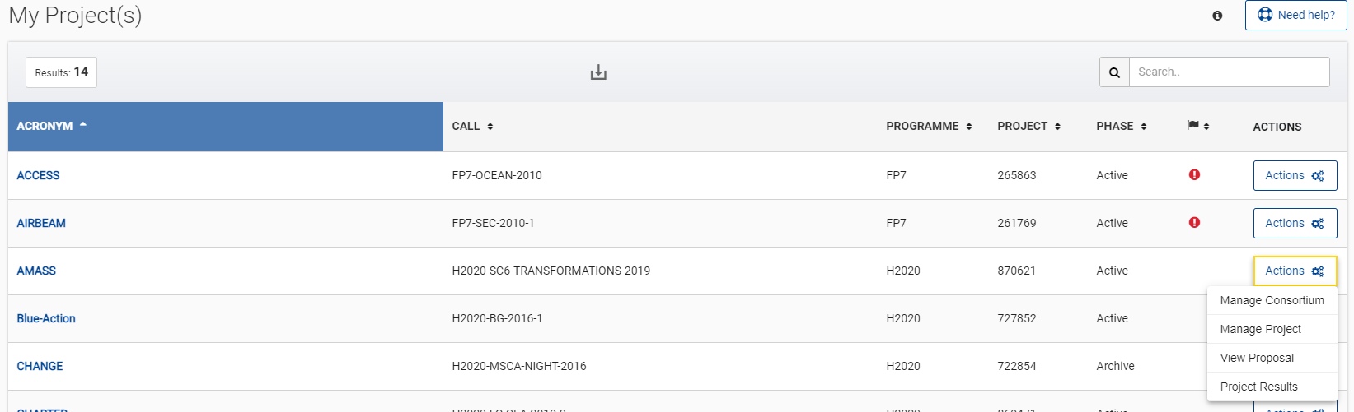

On the next screen you’ll find the Periodic Reporting.
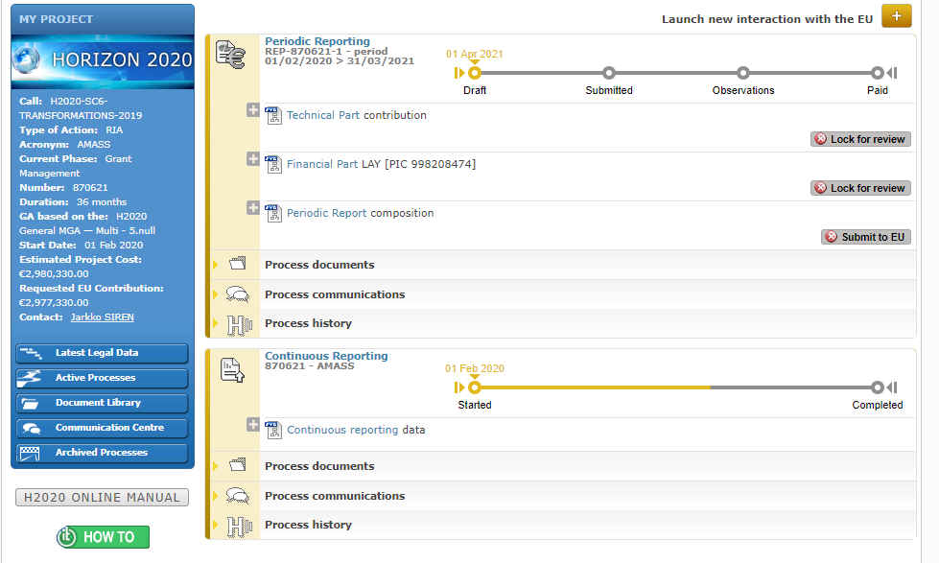
Beneficiaries must complete and submit their organization’s financial as part of the periodic report. The individual statements will be combined automatically by the system into a consolidated financial statement.
If you fail to do so, your costs will be considered 'zero' for this reporting period (though you can declare them in the next reporting period).
You can fill in your financial statement by clicking on “Financial Part” next to the name of your organization. For each cost category please fill in the total amount spent.

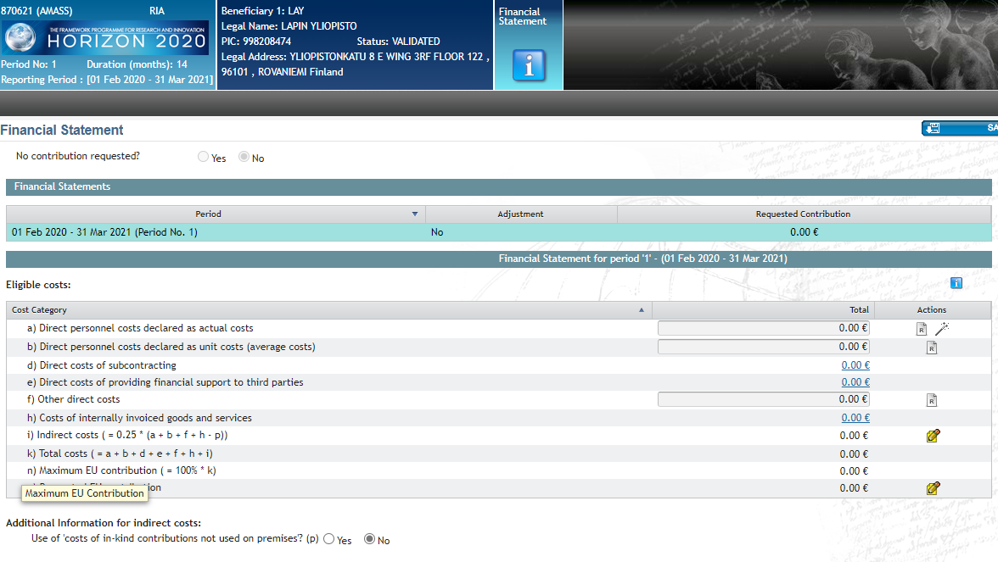

Explanation of the use of resources
Explain in your financial statement how the resources were used during this period.
A. Direct personnel costs- line a)-b)
- Declare here your direct personnel costs a) as actual costs or b) as unit costs (average costs). Please check the conditions for both in the AMGA, see link on page 1
- You only need to supply data on the person-months per work-package (not per deliverable).
- At this stage, you don't have to provide details like names, level of experience etc. (though we may ask you to later).
- Use of in-kind contributions from third parties: if you need to report any related personnel costs, the system will prompt you for details of the costs, name and type of third party, and whether or not the costs were planned in Annex 1 or not.
If the costs were not planned, you must give more explanation.
B. Direct costs of subcontracting - line d)
- In this pop-up, break down the total direct costs for the period into the costs for individual subcontractors, under Unforeseen subcontracting not indicated in the grant agreement (Annex 1) (in addition to the information provided in the technical report - part.1.2).

A + D Direct costs of Third Parties (not linked third parties)
- Declare direct cost related to in-kind contributions from third parties in the pop up appearing in the columns for personnel and/or other direct costs, depending of the type of cost.
- If you used any unforeseen in-kind contributions, either for payment or for free, as well as describing them in the technical report (par.1.2), you must specify here the cost of the resources.
C. Direct cost of providing financial support – line e)
This concerns "cascade funding" and prizes (Article 15, GA). Not applicable for this project.
D. Other direct costs – line f)
You should detail (part of) the costs of goods, works or services in line f9 (Article 10, GA) according to the following rules:
- If costs declared under "other direct costs" are equal to or less than 15% of the personnel costs, you are claiming for this reporting period, you do not need to provide an explanation (though you must still keep all the proof you have of any costs you declare as eligible, in case you are audited).
- If costs declared under "other direct costs" are higher than 15% of these personnel costs, then you must explain other major direct cost items (This means costs declared in your accounts according to your internal accounting practices.) in the table provided in the pop up in line f).
You must explain all items apart from those that add up to less than 15% of your personnel costs. Start from the highest-value cost items.
If you are reporting other direct cost items, you must provide:
- if indicated in the DoA – a simple reference to the DoA
- if not indicated in the DoA – cost/amount per item, description of the item, nature of item (travel, equipment, other goods & services), work package(s), project relevance/explanation
Example
- Personnel costs: €100 000
Other directs costs: €35 000
- Since the other direct costs represent 35% of the personnel costs, you must justify an amount representing 20% of the personnel costs, i.e. €20,000.
- If the €35 000 is the sum of items recorded in the accounts (e.g. €8 500 + €7 500 + €6 500 + €5 500 + €4 000 + 3 x €1 000)...
... you must list and justify the items €8 500, €7 500 and €6 500.
- The remaining amount (a total of €12 500) is less than 15% of the personnel costs, so no details are required for it.
E. Costs of internally invoiced goods and services - line h)
Please read the conditions in the AMGA, see http://ec.europa.eu/research/participants/data/ref/h2020/grants_manual/amga/h2020-amga_en.pdf page 101
F. Indirect costs – line i)
These costs are calculated automatically.
G. Requested EC contribution – line o)
This is calculated automatically.
Save and Submit
Once finished please save and press the button ‘Lock for Review’. An automatic e-mail will be sent to your Financial Signatory (FSIGN). The FSIGN can check the financial statement and sign it electronically when approved.
If you do not have appointed an FSIGN yet, please take care of it. Click on “Actions” and then on “Manage Consortium”:
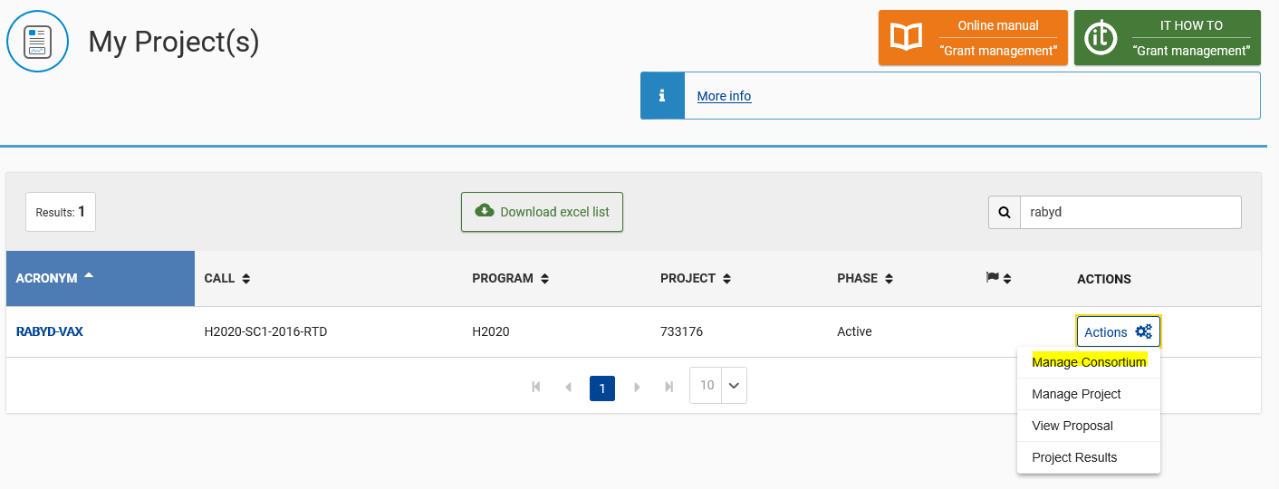

There you can click on “Edit Roles” within your organization and add the role of FSIGN. You will get a list of people that is assigned the role of FSIGN within your organization. Please select one FSIGN for this project.
If no FSIGN list is present, you should ask the LEAR of your organization to create these roles on institutional level.

